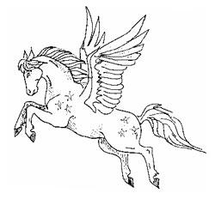
Orderform for mPOD

Date : ………………………………………………….
First & Last Name :……………………………………
Number of Jumps: …………………………………….
Email address :………………………………………….
Dealer Name :…………………………………………..

Delivery Address www.pgasus.be

Street + number : ……………………………………….
Zip Code + City : ……….………………………………
Country : ………………………………………………..

Rig Information

Harness type / model :………………………………….
Harness Serial number :…………………………………
Main Canopy Type & Size :..…………………………..
How does this canopy fit into your original bag ? Hardly (I have to push to get it packed).
Normal (packs smoothly)
Easily (space left after inserting into the bag)
Do you have the impression the original bag is ? Too Big ? OK ? Too Small ?
Standard color is black. If you want a different color, note here but add 10 € to your cost.

Measurements original bag:
Unit of measurement : cm - inch

- Height :
- Depht :
- Width :
- Length closing flap :
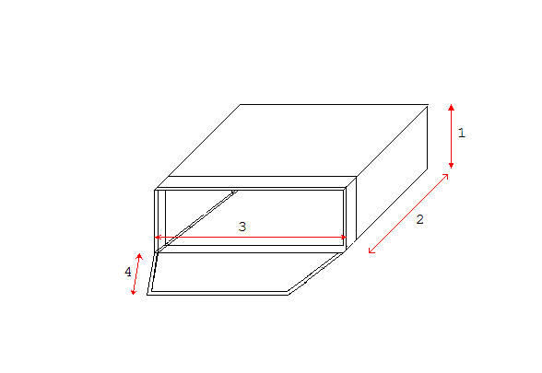
After order placement, an order confirmation will be sent by email. Prepayment must be done prior to sending the finished product.

